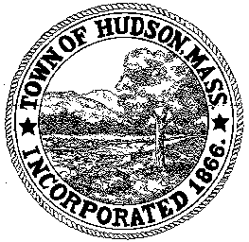

BOARD OF HEALTH
78 Main Street
Hudson, MA 01749
(978) 562-2020
Meeting Agenda
February 14, 2012
7:00 PM

- Preliminaries
1.1 Open Meeting
1.2 Roll Call

2.0 General Business
2.1 Variance Request – Sakura Restaurant

2.2 Housing Update – 130 Central Street (Robert Jordan)

2.3 Second Annual Hudson Cook-off
2/16/2012

2.4 Minutes January 31, 2012

2.5 Office Help

3.0 New Business
3.1 Voucher BOH 021412 $1660.50

4.0 Old Business

5.0 Correspondence

6.0 Adjournment

Next Meeting February 28, 2012

